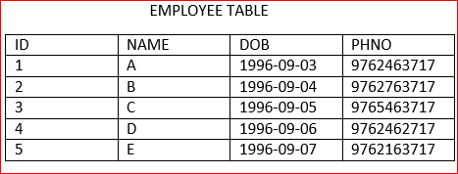

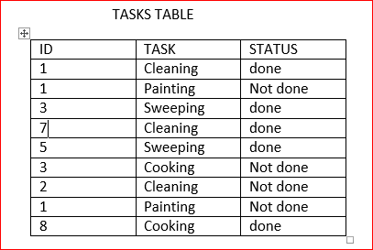

1. Create 2 tables with the above details.





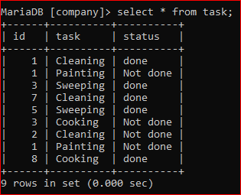

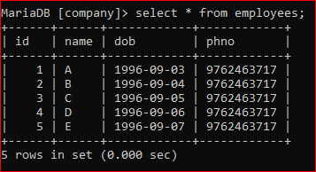

1. Update the Column name of PHNO to MOBILE.

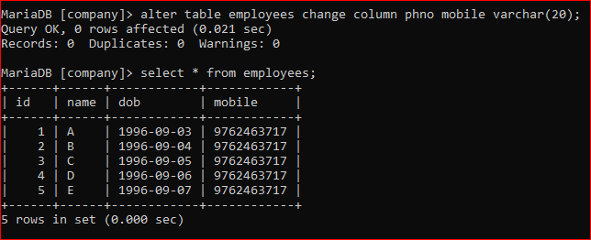

1. Find the person who has did maximum tasks.

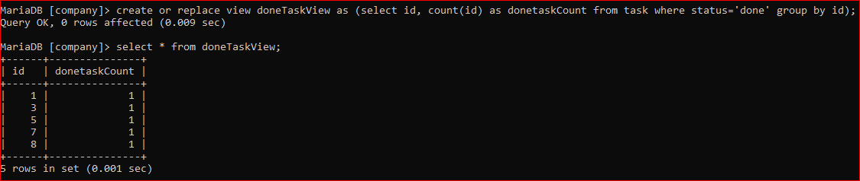

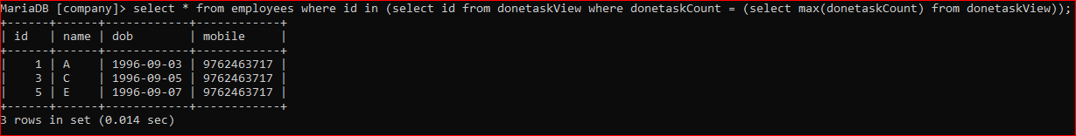

1. Find the list of persons who has not done the tasks.

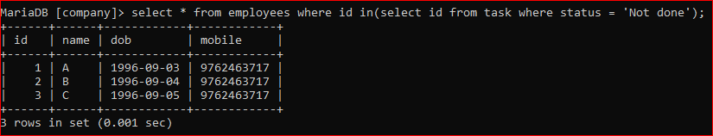

1. find the details of the elder person.

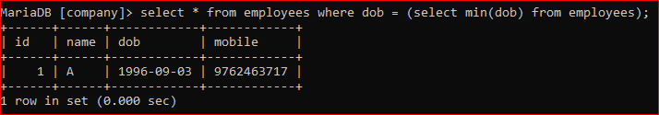

1. create a virtual table containing the details of the persons who has completed the tasks.

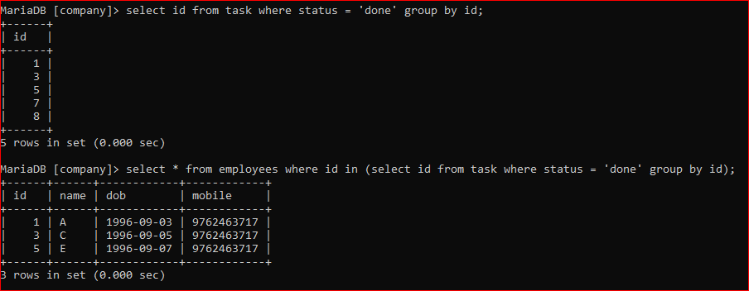

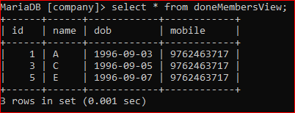

7. Find the count of tasks available.

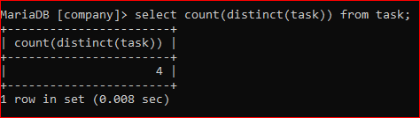

8. find the count of persons in the tasks table whose details are not there in the employee table.

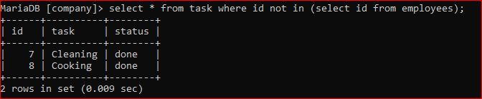

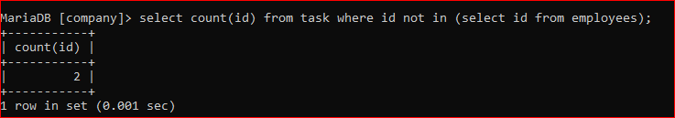

9. Drop the virtual table.



10. Remove the rows from both the tables without using TRUNCATE.

